MERN Stack Web Development

Assignment # 6: REACT CRUD APPLICATION
Submitted By : Maryam Shaikh
Roll No: HM-B3-S2-2026-160233
Project Title: Task Management App (React)

1. Introduction
The Task Management App is a web application developed using React JS, Axios, JavaScript, and CSS. The purpose of this project is to help users manage their daily tasks easily.
The application allows users to add new tasks, edit existing tasks, delete tasks, and mark tasks as completed. It retrieves sample tasks from a public API using Axios and displays them dynamically on the webpage.
The application also includes input validation to prevent empty tasks from being added. If the user tries to add an empty task, an error message appears below the input field and automatically disappears after 10 seconds.

3. Technologies Used
React JS: Used to develop the user interface and manage application components.
JavaScript: Used to implement application logic, event handling, and task operations.
Axios: Used to send HTTP requests to the public API for retrieving, creating, updating, and deleting tasks.
CSS: Used to style the application, task cards, buttons, error messages, and responsive layout.
JSONPlaceholder API: A free testing API used to retrieve sample task data.

4. Project Features

4.1 Fetch Tasks
The application retrieves sample tasks from the JSONPlaceholder API using an Axios GET request. The fetched tasks are displayed when the application loads.
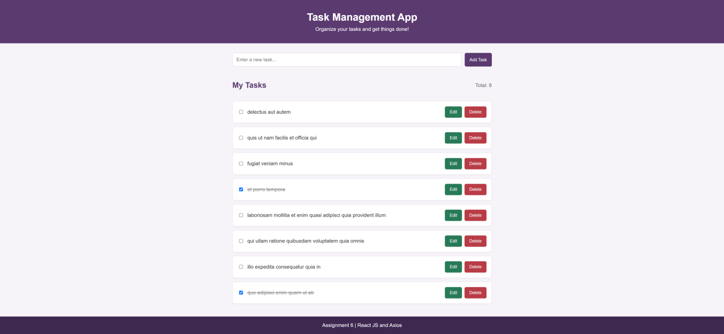

4.2 Add Tasks
Users can enter a task in the input field and click the Add Task button. The new task is added to the task list and displayed on the webpage.
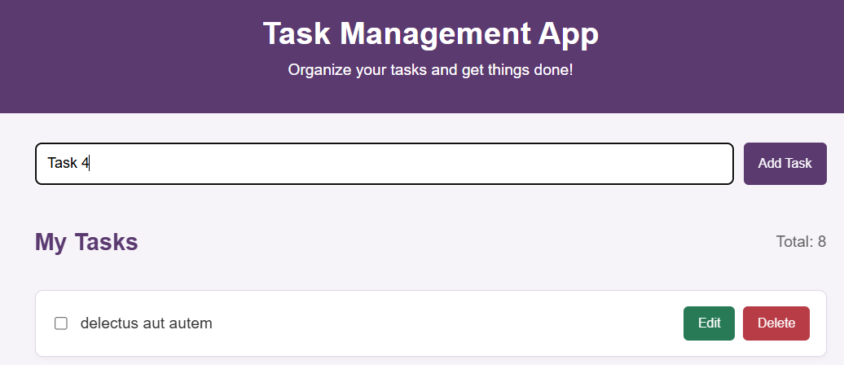

4.3 Edit Tasks
Users can click the Edit button to modify an existing task. After changing the task name, they can click Save to update it or Cancel to discard the edit.
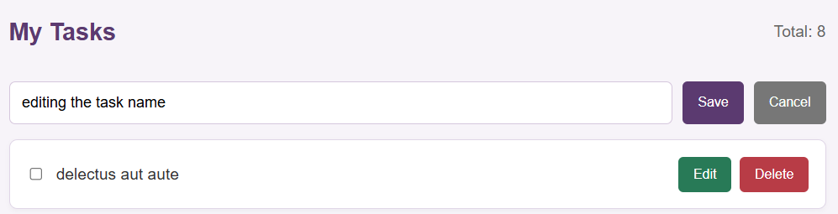

4.4 Delete Tasks
Users can click the Delete button to remove a task from the displayed task list.
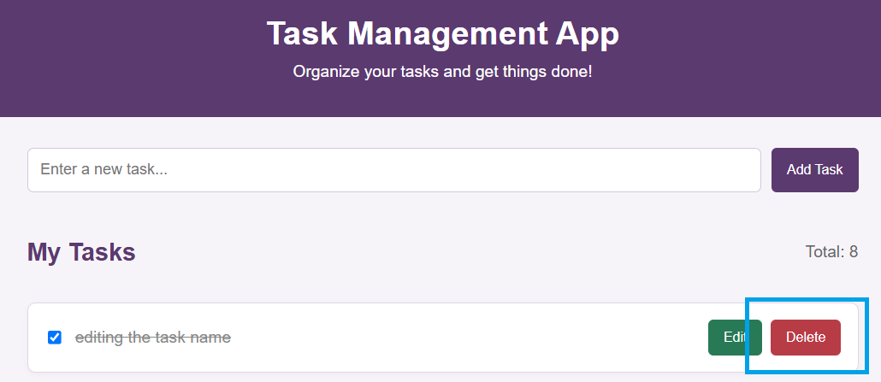

4.5 Mark Tasks as Completed
Each task has a checkbox. Users can check the box to mark a task as completed. Completed tasks are displayed with a line through their text.
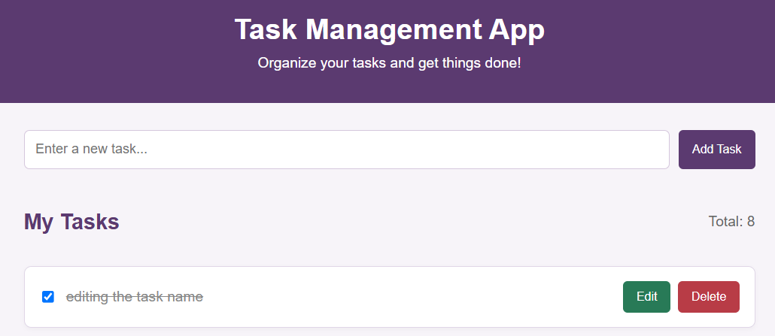

4.6 Input Validation
The application checks whether the task input is empty or contains only spaces. If the input is invalid, the application prevents the task from being added and displays an error message.
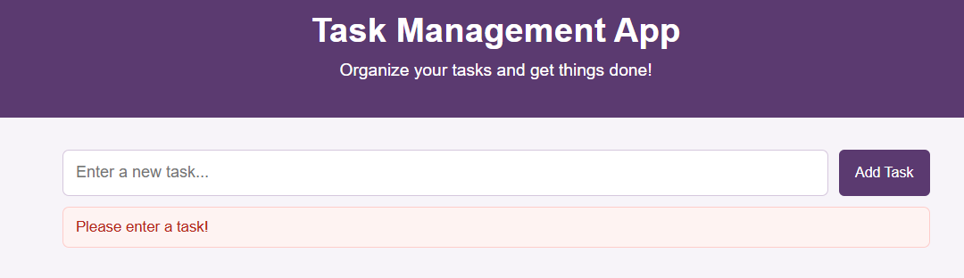

4.8 Task Counter
The application displays the total number of tasks currently present in the list.
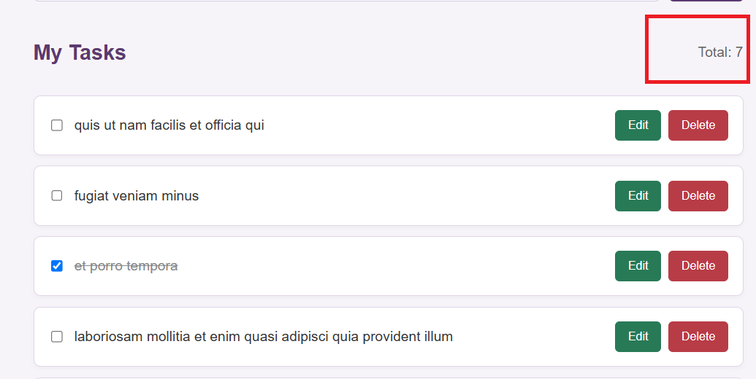

4.9 Responsive Design
CSS media queries are used to adjust the layout for smaller screens, making the application easier to use on desktop computers, tablets, and mobile devices.
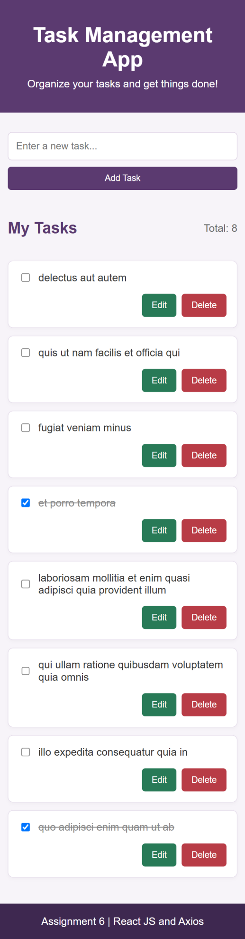

5. API Integration
API Name: JSONPlaceholder
API URL: https://jsonplaceholder.typicode.com/todos
HTTP Methods Used: GET, POST, PUT, PATCH, DELETE
The application uses Axios to communicate with the API.
- GET: Retrieves the sample tasks.
- POST: Sends a request to create a new task.
- PUT: Sends updated task information.
- PATCH: Sends a request to update a task's completion status.
- DELETE: Sends a request to delete a task.
These requests demonstrate how a React application can communicate with a REST API.

6. React Concepts Used

6.1 Functional Components
The application is divided into functional components to make the code easier to understand and manage.
The main components are:
- App: Manages the task list, API requests, and application state.
- TaskForm: Provides the input field and Add Task button.
- TaskList: Displays the task cards and their available actions.

6.2 useState Hook
The useState hook is used to store and update the task list, input values, loading status, error messages, and editing information.

6.3 useEffect Hook
The useEffect hook runs when the application component first loads and calls the function that retrieves tasks from the API.

6.4 Props
Props are used to pass task data and functions from the parent component to child components. For example, TaskForm receives the function for adding a task, while TaskList receives the task list and task action functions.

6.5 Event Handling
Event handlers respond to user actions such as clicking buttons, typing in input fields, checking completion boxes, and submitting the form.

6.6 Array Methods
The map() method is used to display task cards and update existing tasks. The filter() method is used to remove a task from the displayed list.

6.7 Asynchronous Operations
The async and await keywords are used with Axios requests to handle API communication and process responses.

7. CRUD Operations
CRUD stands for Create, Read, Update, and Delete.
Create: A user enters a task and clicks Add Task. The application sends an API request and adds the task to the displayed list.
Read: The application retrieves sample tasks from the API and displays them on the webpage.
Update: A user edits a task or changes its completion status. The application sends the appropriate API request and updates the displayed data.
Delete: A user clicks Delete. The application sends a delete request and removes the task from the displayed list.
These operations demonstrate the basic working of a task management system.

8. Input Validation and Error Handling
Input validation ensures that users cannot add an empty task.
When the Add Task button is clicked, the application checks the input using the trim() method. This method removes leading and trailing spaces.
If the input is empty, the application displays the message "Please enter a task!" below the task input field. The error message uses a red text color to make it noticeable and automatically disappears after 10 seconds.
The application also displays error messages when an API request fails. This helps users understand when an operation could not be completed.

9. Working of the Application
The application works through the following steps:
- The user opens the Task Management App.
- The application retrieves sample tasks from the API using Axios.
- The tasks are displayed as individual cards.
- The user can add a new task using the input field.
- If the input is empty, an error message appears and disappears after 10 seconds.
- The user can edit an existing task and save the changes.
- The user can mark a task as completed using the checkbox.
- The user can delete a task using the Delete button.
- The total task count updates when tasks are added or removed.

10. Conclusion
In conclusion, the Task Management App demonstrates the basic concepts of React JS, including functional components, props, state management, and event handling. Axios is used to communicate with a public API, while CRUD operations allow users to manage tasks through the interface.
The application also includes input validation, automatic error message removal, and a responsive design. Completing this assignment improved my understanding of React development and API integration.

